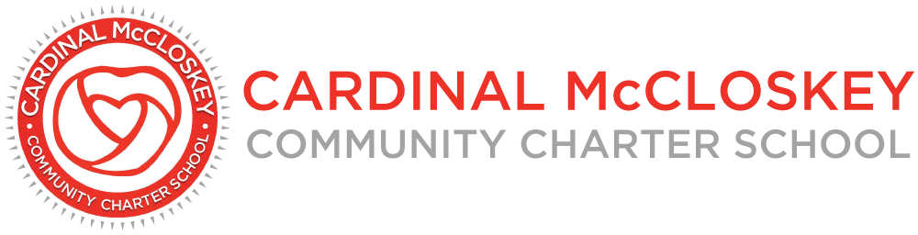

Cardinal McCloskey Community Charter School
Board of Trustees Meeting Minutes
July 15, 2026

- Opening Items

- Call to Order

The meeting was called to order at 3:31 PM by Mr. Angel Audiffred.

- Roll Call

Roll call was conducted by Dr. Bill Ursillo. A quorum was established.

Present Absent
Angel Audiffred X
Dr. Reva Gershen-Lowy X
Dr. William Ursillo X
Carolyn Telesmanich X* (virtual)
Happy Laskar X

Charter School Staff: Dr. Mary Anne DeVivio, Christian Adamkiewicz, Jerry Sgambati, and Lynsey Bailey
Guests: Svetlana Gnesina and Missy Couch

- Approval of the July 2026 Board Meeting Agenda

Directors reviewed the proposed agenda for the July 2026 board meeting. Dr. Ursillo motioned to approve the agenda as presented. Ms. Telesmanich seconded. All aye, and the motion carried unanimously.

- Approval of the June 2026 Board Meeting Minutes

Mr. Audiffred presented the minutes from the June 3, 2026, board meeting. Dr. Ursillo motioned to approve the minutes as submitted, Dr. Gershen-Lowy seconded, and the motion carried unanimously.

- Principal’s Report

Dr. Mary Anne DeVivio presented the Principal’s Report. Keynotes included:
- A successful Enrollment Day was held this month. 100 students are fully enrolled.
- Summer school is progressing well.
- First day of school for 2026-2027 is September 10th.
- The team is awaiting the response from SUNY regarding the state assessment scoring issues.
- CMCCS was shortlisted as a top charter school in an education magazine; the publication is expected in September.
- Committee Reports

- Academic Committee Report: Dr. Bill Ursillo

Dr. Ursillo, Chair of the Academic Committee, presented the June 2026 Academic Committee report. Keynotes included:
- The committee met on June 18, 2026.
- Bloomberg grant awarded for summer programming.
- ELA and Social Studies curriculum pilot will be adopted and continue this school year.
- The Committee discussed ELA scores, next steps, and strategies to better support academic teams throughout the school year.

- Finance Committee Report: Dr. Reva Gershen-Lowy

Dr. Gershen-Lowy, Chair of the Finance Committee, presented the June 2026 Finance Committee report.

The Finance Committee reviewed the financial reports for the month.

Ms. Gnesina presented the financial statements for May 2026. As of May 31, 2026, there is a projected year-end deficit of approximately $100K, primarily due to unexpected facilities costs and higher-than-budgeted personnel bonus payouts, including a non-cash adjustment. Additional keynotes included:
- Revenue exceeded budget due to strong enrollment and food program performance.
- Expenses exceeded budget due to personnel changes and food program costs.
- The Metropolitan Bank balance is approximately $6.7M (excluding escrow), with approximately $20K earned in interest for the month.

- Governance Committee Report: Mr. Angel Audiffred

Mr. Audiffred, Chair of the Governance Committee, shared that there was no committee meeting held in June, and therefore, no June 2026 Governance Committee report.

Governance matters, including board members assignments, were discussed.

- New Business

- CSI Letter

The board discussed the conclusion of Sr. Patricia Broderick’s and Mr. Jim McCarthy’s board service effective June 30, 2026, future board recruitment, and SUNY expectations regarding independent board members and potential conflicts of interest.

- CACFP Update

Dr. Mary Anne DeVivio reported that students are receiving meals, leftover food is being distributed to families, and the school is receiving reimbursement through the program.
- Action Items

Board officer appointments were presented. Board officer proposals include:
- Board Chair: Mr. Angel Audiffred
- Vice Chair: Dr. Bill Ursillo
- Treasurer: Dr. Reva Gershen-Lowy
- Secretary: Ms. Happy Laskar

Dr. Gershen-Lowy made a motion to approve the board officer slate as presented. Mr. Audiffred seconded. All aye, and the motion carried.

- Partner’s Report

The Partner Report was received.

- Public Comment

There was no public comment.

- Executive Session

Mr. Audiffred made a motion to enter executive session to discuss a contract issue and seal the minutes. Ms. Laskar seconded. Dr. Ursillo conducted the roll call vote:

- Angel Audiffred: Aye
- Dr. Reva Gershen-Lowy: Aye
- William Ursillo: Aye
- Carolyn Telesmanich: Aye
- Happy Laskar: Aye
The motion carried unanimously. Executive session began at 4:05 PM. All trustees entered into the executive session and participated in the discussion. Mr. Audiffred made a motion to end executive session and enter open session. Dr. Gershen-Lowy seconded, and the motion carried unanimously. Open session began at 4:47 PM.

Mr. Audiffred reported that the board discussed and agreed upon the board meeting cadence for this school year to remain at 3:30 PM EST on the third Wednesday of each month.

- Action Items

- Approval of the CMCCS Chair Authorization for OLR Lease Agreement

Mr. Audiffred made a motion to authorize the Chairman of the board to sign the OLR lease agreement following the Finance Committee review and approval of the lease and related costs. Ms. Happy Laskar seconded. All aye, and the motion carried.

- Adjournment

Dr. Ursillo motioned to adjourn the meeting, and it was seconded by Ms. Telesmanich. The motion carried unanimously, and the meeting was adjourned at 4:48 PM.

Next Meeting: The next board meeting will be Wednesday, August 5, 2026, at 3:30 PM

