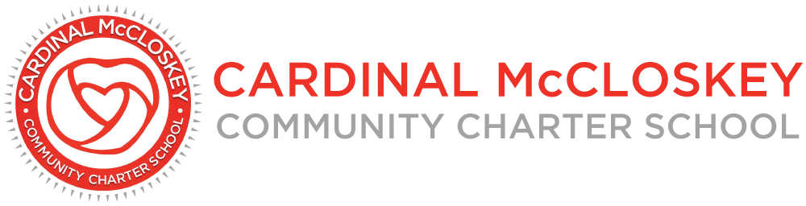

Cardinal McCloskey Community Charter School
Board of Trustees Meeting Minutes
August 5, 2026

- Opening Items

- Call to Order

The meeting was called to order at 3:33 PM by Mr. Angel Audiffred.

- Roll Call

Roll call was conducted by Dr. Bill Ursillo. A quorum was established.

Present Absent
Angel Audiffred X
Dr. Reva Gershen-Lowy X
Dr. William Ursillo X
Carolyn Telesmanich X* (virtual)
Happy Laskar X

Charter School Staff: Dr. Mary Anne DeVivio, Jerry Sgambati, and Lynsey Bailey
Guests: Svetlana Gnesina and Nicole Morrissey

- Approval of the August 2026 Board Meeting Agenda

Directors reviewed the proposed agenda for the August 2026 board meeting. Dr. Ursillo motioned to approve the agenda as presented. Dr. Gershen-Lowy seconded. All aye, and the motion carried unanimously.

- Approval of the July 2026 Board Meeting Minutes

Mr. Audiffred presented the minutes from the July 15, 2026, board meeting. Dr. Gershen-Lowy motioned to approve the minutes as submitted, Ms. Telesmanich seconded, and the motion carried unanimously.

- Principal’s Report

Dr. Mary Anne DeVivio presented the Principal’s Report. Keynotes included:
- Enrollment is on track with 445 students enrolled with all registration paperwork complete. 16 remain in progress.
- Secondary state test scores were just released, and Mr. Jesse Ronda is currently pulling the data for analysis.
- The scoring errors received another round of analysis from a third party. They confirmed 25% of the scores include errors. This information has since been sent to SUNY and a response was received. SUNY is opting not to address the issue but shared that all context is helpful, and the school should share the information with the SUNY authorizing board.
- Dr. DeVivio questioned how to best share the information with families. Including a letter from the state is in consideration.
- Committee Reports

- Academic Committee Report: Dr. Bill Ursillo

Dr. Ursillo, Chair of the Academic Committee, shared that there was no committee meeting held in July, and therefore, no July 2026 Academic Committee report.

Dr. Ursillo shared the update that Ms. Carolyn Telesmanich will now chair the committee. Members remain Carolyn Telesmanich, Reva Gershen-Lowy, Bill Ursillo, and two ad hoc members, Ibet Hernandez and Fortunata Lardo-DiMarco. Dr. Ursillo will share resources with Ms. Telesmanich, and the dates of the committee meetings will likely remain the third Thursday of the month at 2:00 PM.

- Finance Committee Report: Dr. Reva Gershen-Lowy

Dr. Gershen-Lowy, Chair of the Finance Committee, presented the July 2026 Finance Committee report.

The Finance Committee reviewed the financial reports for the month. These are not audited numbers, and may be subject to change slightly.

Ms. Gnesina presented the financial statements for June 2026. As of June 30, 2026, there is a projected year-end deficit of approximately $330K, primarily due to unexpected facilities costs and higher-than-budgeted personnel bonus payouts, including a non-cash adjustment. Without depreciation, there is a projected surplus of approximately $300K. Additional keynotes included:
- Revenue exceeded budget due to strong enrollment and food program performance.
- Expenses exceeded budget due to personnel changes and food program costs.
- The balance sheet is healthy is $6.8M in total assets.
- The Metropolitan Bank balance is approximately $6.3M, with approximately $18K earned in interest for the month.
- There has been about $200K so far in earnings from interested alone over the past year.

Ms. Gnesina reviewed the revised budget for the remainder of FY26 and FY27. The OLR rent, maintenance, utilities, and depreciation have been added to the budget. There is an update projected surplus of $21K.

Dr. Gershen-Lowy highlighted updates on the audit submission. Ms. Gnesina shared that the audit was submitted last week, and the auditors came back with open items. CSBM is reviewing with the school team to gather necessary documents. The goal is to submit all requests by Friday. This process will continue for another month or so, but the audit looks good so far.

- Governance Committee Report: Mr. Angel Audiffred

Mr. Audiffred, Chair of the Governance Committee, presented the July 2026 Governance Committee report.

Governance matters, including the OLR lease and a potential visit by the board to the space, were discussed.

- Action Items

Mr. Audiffred presented the minutes from the executive session portion of the July 15, 2026, board meeting. Dr. Gershen-Lowy made a motion to accept the minutes of executive session as presented. Ms. Telesmanich seconded. All aye, and the motion carried unanimously.

- Discussion

Mr. Audiffred led the Directors in a discussion about the renewal application, scheduled to be submitted next week. The draft will be shared with the board for review prior to submission. The currents gaps include addressing the letter from CSI, the executive summary, and the final budgets.

Mr. Audiffred has been working diligently and transparently with CMCS, specifically with Ms. Beth Finnerty, to support CMCS in the purchase of the Aquinas building and ensure CMCCS remains a tenant of the building and an operational school. CSI has made it clear that if the requirement to amend the bylaws is not met, CMCCS is at risk of non-renewal.

There is a workaround proposal from CMCS to potentially bridge the gap. The proposed amended bylaws would introduce unaffiliated board members. CSI does not agree with the proposal. Mr. Audiffred followed up with Ms. Finnerty to share the concerns of CSI.

The Board discussed various back-up plans. Though the school has been fortunate enough to secure the secondary location at OLR, the board must change the bylaws to meet CSI requirements. Directors discussed various options, including submitting a formal request to CMCS as a full board to amend the bylaws appropriately, enlisting local legislators to serve as mediators to reach a viable compromise, and hosting a CSI intervention. The renewal of the school remains the board’s top priority.

The Directors agreed that all parties should come together to discuss with lawyers present. Dr. DeVivio reiterated that the issue for CSI remains two-fold: the conflict of interest and the sole membership on the part of CMCS. A meeting with all parties and their lawyers will be coordinated hopefully next week. The application submission will be August 14th.

Mr. Audiffred proposed including Catholic Charities or a local legislator. Directors agreed that involvement should start small and grow as necessary.

- New Business

- CACFP Update

Dr. DeVivio will confirm the start date, whether July 1 or October 1. A document will be sent for signature to all board members.

Dr. DeVivio shared that TFA believes CMCCS always “comes out on top” as one of the best schools to train at during summer institute.

- Partner’s Report

The Partner’s Report included a recap on the bylaw amendments.

- Public Comment

There was no public comment.

- Executive Session

There was no executive session.

- Adjournment

Dr. Ursillo motioned to adjourn the meeting, and it was seconded by Dr. Gershen-Lowy. The motion carried unanimously, and the meeting was adjourned at 4:23 PM.

Next Meeting: The next board meeting will be Wednesday, September 16, 2026, at 3:30 PM.

